IMAGE CLASSIFICATION

**Design and Construction of Convolutional Neural Networks Based diseased cell Image classification.**

**Aim of Project: To Classify Malaria Image Using CNN.**

**Abstract:**

1. **Why Malaria is so dangerous**

Malaria in humans can be caused by a number of different parasites – the most dangerous, and the one which is responsible

for over 90% of the worldwide deaths from malaria, is Plasmodium falciparum.

The reason that P. falciparum is so dangerous is because it affects the behaviour of red blood cells. Red blood cells that are

infected with P. falciparum become “sticky”, and as they pass through the the small blood vessels inside the body’s organs

, they become stuck – this process is known as “sequestration”. As the number of red blood cells stuck inside the small blood

vessels increases, blood flow to the organ is reduced, which can result in further complications. When sequestration occurs

inside the blood vessels in the brain, the result is what is clinically recognised as cerebral malaria – complications can include

impaired consciousness, coma and even death.

If diagnosed and treated promptly, most cases of P. falciparum can be resolved quickly and without complications, using oral

medication. However, the parasite can reproduce very quickly, meaning that cases can become more serious within days and

even hours. As such, if P. falciparum infection is suspected, and particularly in high-risk individuals such as young children,

pregnant women and immunocompromised individuals, diagnosis should be sought immediately so that appropriate treatment

can be delivered.

## 2)Helping the world to fight malaria using deep learning with Convolutional Neural Networks.

* Malaria is most commonly found in the **tropical and sub-tropical areas**of Africa, South America, and Asia.
* Despite its fatality, it can be cured if detected early. However, the way to diagnose malaria accurately is by taking
* a drop of blood, smearing it on a slide and then **examining it under a microscope** to look for malaria parasites inside
* the red blood cells.

  
(1) Healthy red blood cell

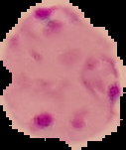

Parasitized red blood cell

The healthcare industry starts to turn to use machine learning and train the image classification model to

help to reduce the burden of macroscopics in resource-constrained regions and improving diagnostic accuracy.

The general machine learning workflow:

1. Examine and understand the data by visualizing those microscope pictures
2. Check whether resolutions are same
3. Equate all resolution
4. Compose the model structure
5. Train the model
6. Model evaluation & model summary

The data set and explanation can be found on Kaggle.

# Data Understanding

The slide images of red blood cells are provided and encrypted in a zip file. We should confirm how many

images are given and what extensions are being provided.

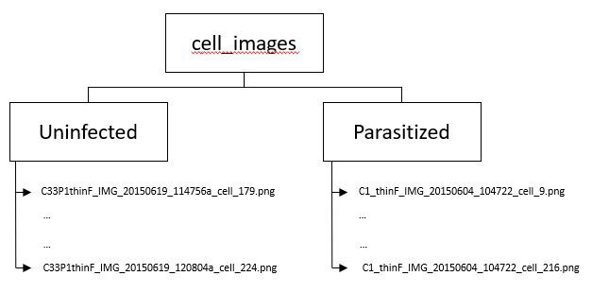

(2) Data in the given Zip file

Once we have removed unnecessary files from the list (other files which are not images). Then let’s observe

the sample images from each class.

One note from plotting these sample images, we can see that **the images are not equal in size and**

**this need fixing** before feeding onto the model.

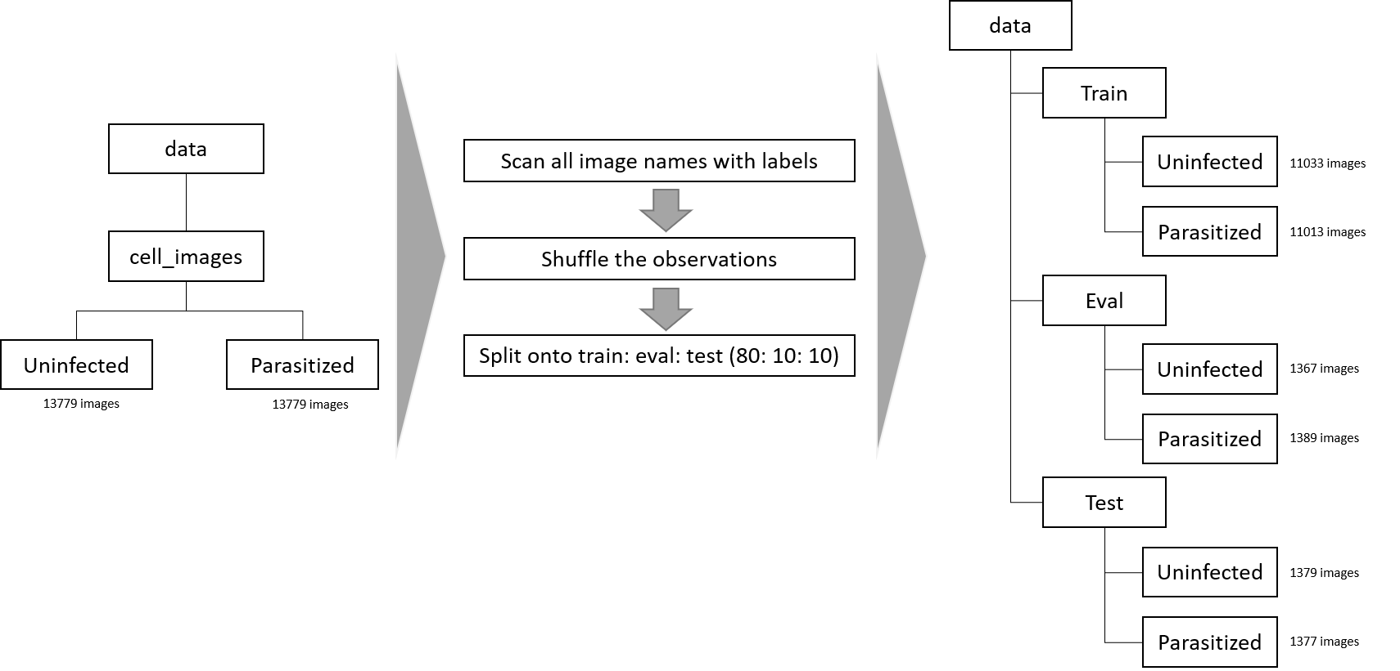

(3) Pre-processing prior to building the data pipeline

I ultimately only scan for file names and labels associated with the images without loading the actual

images onto memory.

I Collectively used Google Collaboratory which is strongest and most purposely used platform for

Machine Learning, Artificial Intelligence, Data Analytics & Industry 4.0’

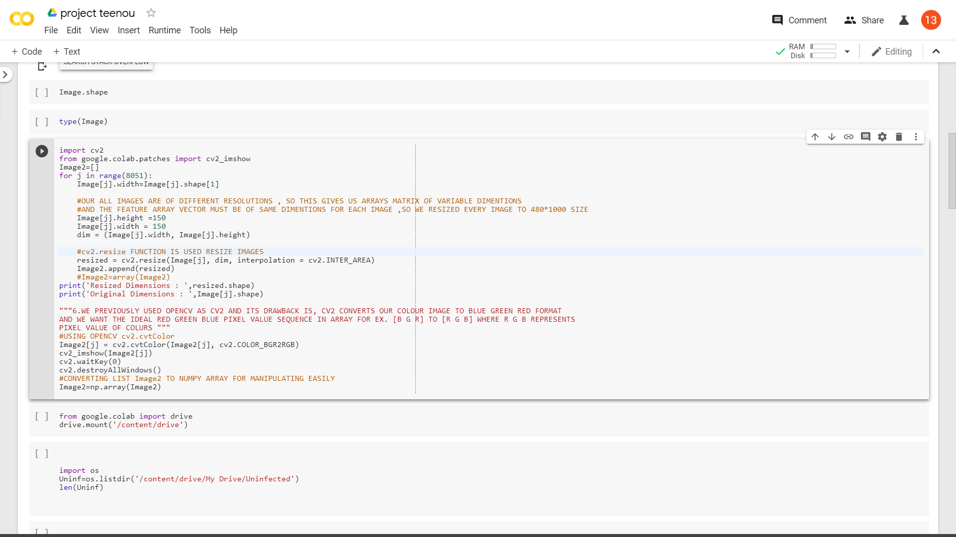

IMAGE RESIZE

Our All Images Are of Different Resolutions, so this Gives Arrays Matrix of Variable Dimensions.

And the Feature Array Vector Must of the Same Dimensions for Each Image, So We Resized Every

Image To 150*150 Size

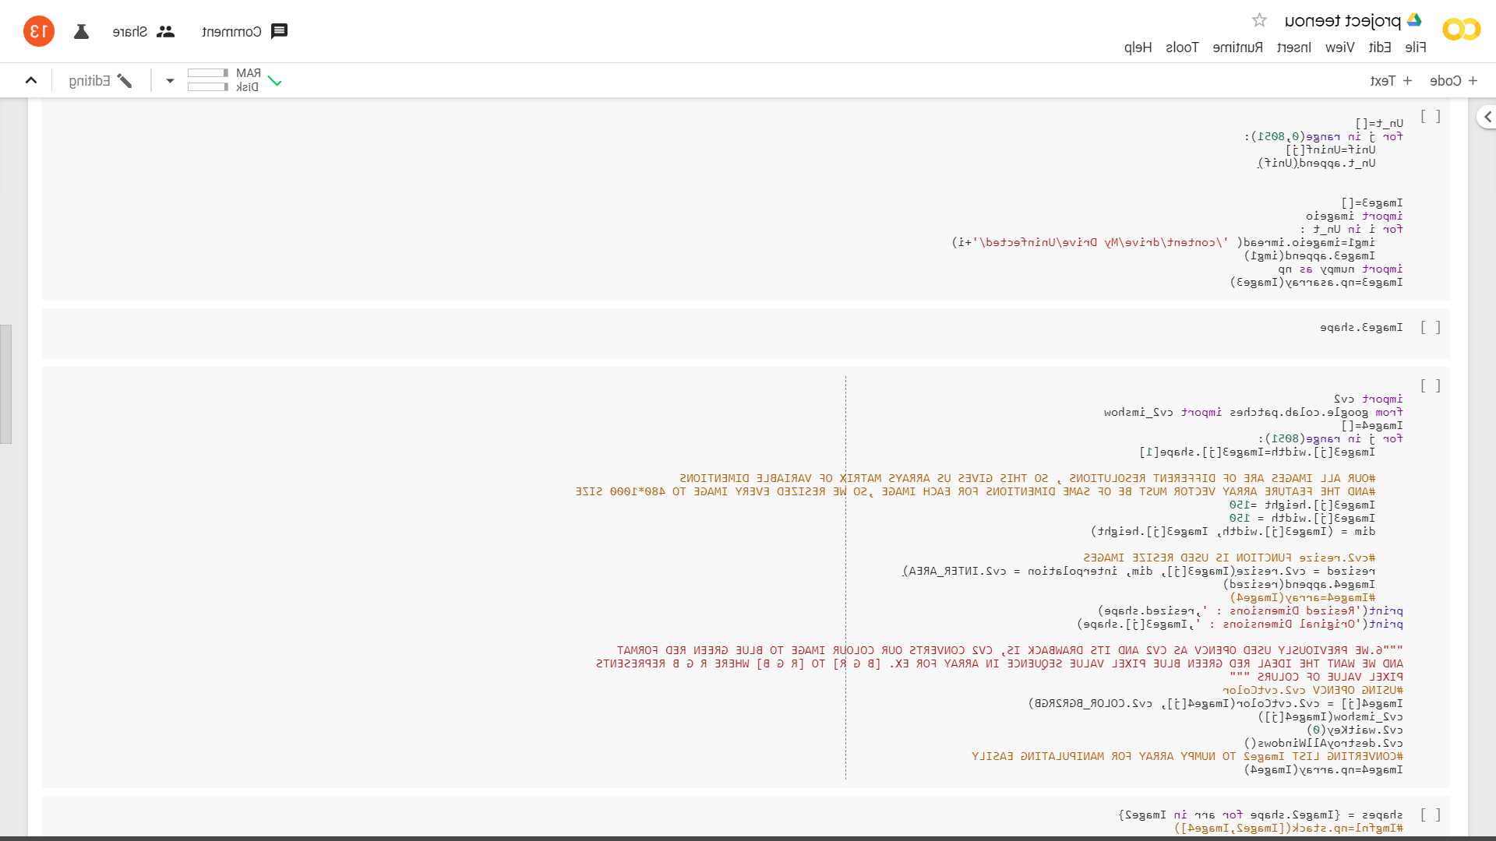

Convolutional Neural Networks Model Architecture for Classification.

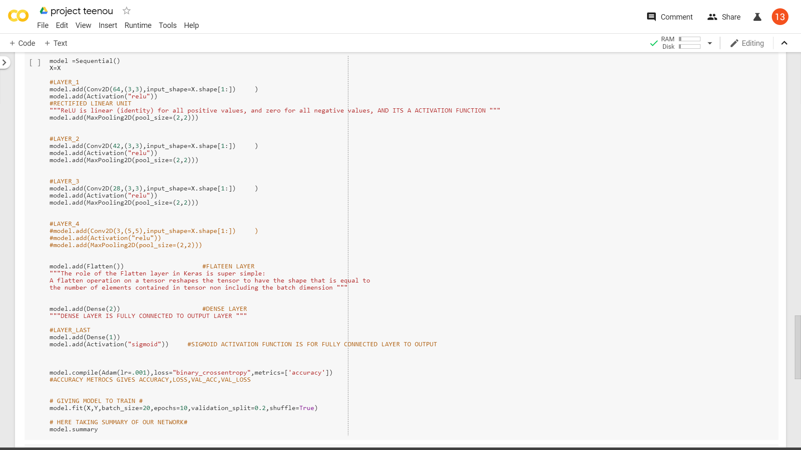

CLASSIFICATION TESTING OF RANDOM IMAGE TAKEN FROM INTERNET

If it comes in mind to check whether the model is trained properly after all the together running,

an image is passed to trained model for the classification.

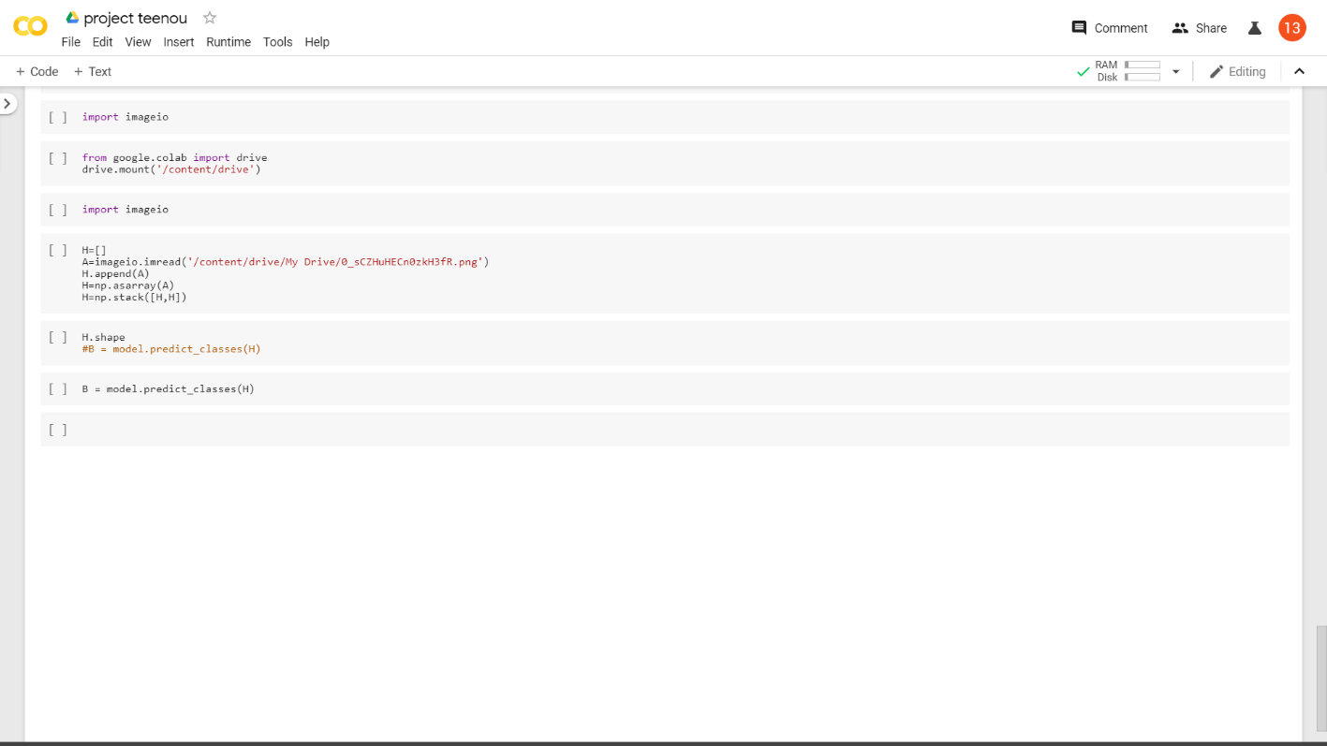

And here we constructed and trained the supermodel of Image Classification of Malaria Diseases

using Convolutional Neural Networks with Accuracy…………………………97.4%.